- MAIN PAGE

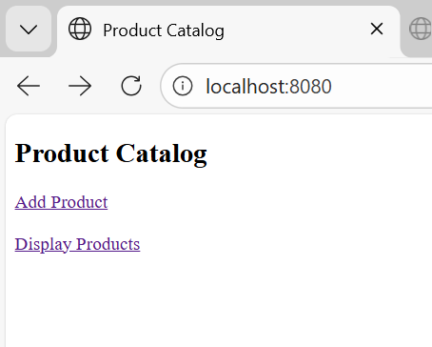

- AFTER CLICKING “ADD PRODUCT”

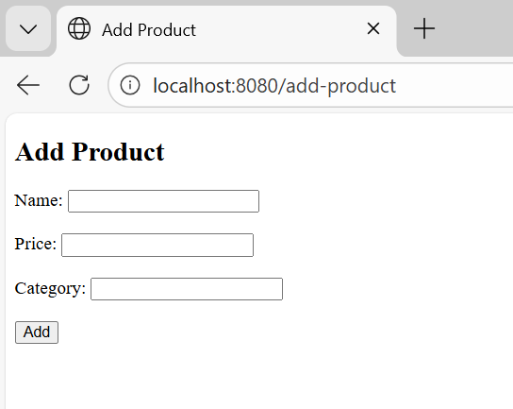

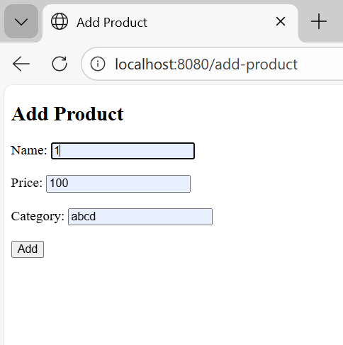

- AFTER CLICKING “ADD” BUTTON

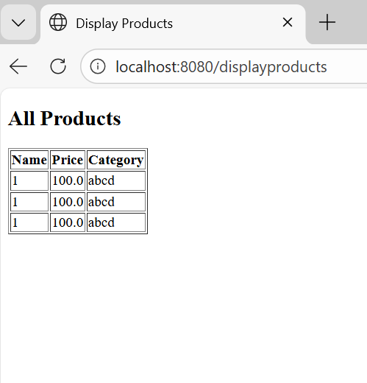

- FROM MAIN PAGE, CLICKING “DISPLAY PRODUCTS” BRINGS

